EXPERIMENT-3

AIM:
Perform basic Image Handling and processing operations on the image is to read an image in python and Convert an Image to show outline using Canny function.
PROGRAM:
import cv2
from tkinter import Tk, filedialog
# Hide the Tkinter window
Tk().withdraw()
# Open a file dialog to choose an image
file_path = filedialog.askopenfilename(
title="Select an Image",
filetypes=[("Image Files", "*.jpg *.jpeg *.png *.bmp")]
)
# Check if a file was selected
if not file_path:
print("No image selected!")
exit()
# Read the image
img = cv2.imread(file_path)
# Check if the image was loaded
if img is None:
print("Error: Unable to load the image!")
exit()
# Convert to grayscale
gray = cv2.cvtColor(img, cv2.COLOR_BGR2GRAY)
# Apply Canny Edge Detection
edges = cv2.Canny(gray, 100, 200)

# Display images
cv2.imshow("Original Image", img)
cv2.imshow("Canny Edge Detection", edges)
# Wait until a key is pressed
cv2.waitKey(0)
# Close all windows
cv2.destroyAllWindows()
INPUT:
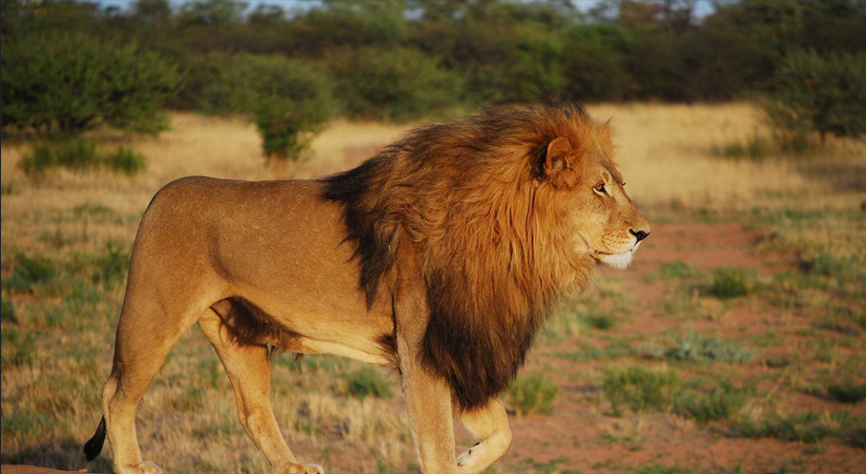
OUTPUT:
